Battlefield Choir
2020 Spring Program Ad
Sales

Battlefield Choir Spring Program Ad Sales

Hello and thank you for your interest in supporting the Battlefield Choir Spring Show Program!!

- We are selling ads to cover the cost of printing our spring show program and also to allow our student to fundraise money to cover their choir expenses.
- We are asking each student to sell $25 of ads to cover the program cost. Any amount over the $25 will be shared with the student. 50% of those sales will be credited to the student’s fundraising. The student that sells the most will receive $100 Amazon gift card. 2nd place will be $50!
- We will only be accepting digital copies of ads. We are not able to create ads. The business/patrons will be responsible for creating and submitting the ads on line. With close to 80 ads in last year’s program, it is difficult to put together the program and keep track of all paper ads. A business can hand you a business card, or a paper document, but it will be your responsibility to scan it in and send it to the program email. It is much easier to find documents on the computer, than from a stack of papers.
- All ads will be due no later than Saturday, April 18th. Since everything will be sent electronically, this will give the boosters enough time to verify the ads. Please make sure the online form is complete as well, so we have records of what we need.
- All money for ads will be due on Saturday, April 18th as well.
- Ad pricing is listed below

How to Sell and Submit an Ad (Full, Half, Quarter, Business Card or Patron)

- Approach businesses, neighbors, friends, etc. and tell them that you are selling ads to cover the cost of our amazing spring show program and also raising funds to pay your choir expenses.

- Once the business, patron or parent agrees to buy an ad. Do the following:
  - Have them fill out Battlefield High School 2020 Choir Spring Program Advertisement Form (the form is below). Attach the payment for the ad to this form and put it in an envelope marked “Spring Program Ad” and drop it in the mailbox safe in the front of the choir room
  - Go to the link: https://www.formpl.us/form/943126012 and record the sale of the ad. The business or you can load the ad via this link or can email it to bhschoirprogram2020@gmail.com
  - Keep track of your sales on the Battlefield Choir Program Sales Summary (the form is below) when you are done selling ads put your summary in an envelope and drop it in the mailbox safe in the front the choir room
  - All ads must be submitted via the link or email and must be photo ready. We will not be able to make any changes or edits to ads.
  - Examples of what the completed forms should look like as well as what you will see when you click on the link are below
  - Ads with payment must be received by April 18th. Any ads that we do not have payment for by that time will not be printed. Also, if we have a payment and no ad by the 18th the payment will be considered a donation to the Battlefield Choir Boosters.
  - Give a copy of the thank you note below to the business for their records.

Frequently Asked Questions

Will the book be printed in color?
Yes!

Who can I sell ads to?
ANYONE! You can sell an ad to any business or any person. Many parents and family members like to buy personalized advertisements for SENIORS! This is a great souvenir for our Senior Choir Members!

How do I scan in an ad?
If you have a scanner at home, that works well! If not, there are a few really great apps for an iPhone that use the camera as a scanner. One that we use often is called Genius Scan (and it’s free!).

Any other questions can be emailed to bhschoirprogram2020@gmail.com

We will respond to your questions promptly!

BHS Choir 2020 Program Advertisement Price/Size Sheet  Ad Type *Ad Size Cost  Full Page 7 ¾” x 10 ¼“ $175  Half Page 5” x 7 ¾” $100  Quarter Page 3 ¾” x 5” $65  Business Card (1/8 Page) 2 3/8” x 3 ¾” $45  Patron Ad Name Only $15  *Ad size is subject to slight dimensional changes. | BHS Choir 2020 Program SENIOR PAGE Price  Ad Type *Ad Size Cost  Full Page 7 ¾” x 10 ¼“ $50  Half Page 5” x 7 ¾” $25  Quarter Page 3 ¾” x 5” $10  * Ad size is subject to slight dimensional changes.

Any ads that cannot be submitted should be emailed to bhschoirprogram2020@gmail.com
Please include all the same information as stated on the form.

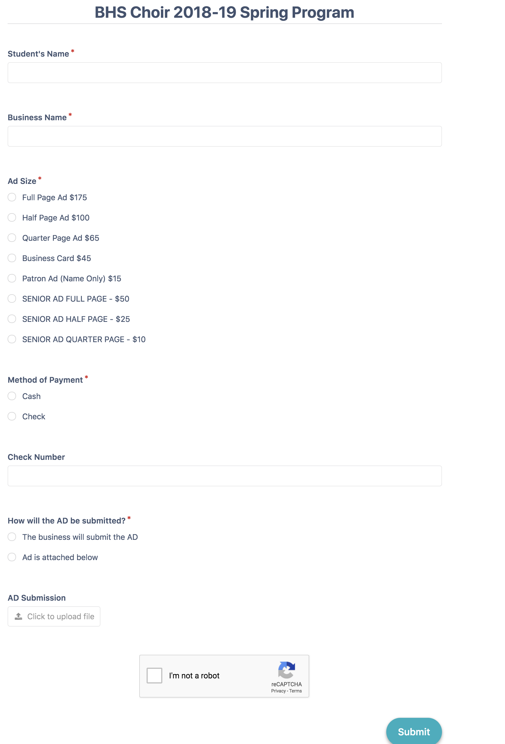
EXAMPLE OF WHAT YOU WILL SEE WHEN YOU CLICK ON OUR LINK

Battlefield High School

2020 Choir Spring Program Advertisement Form

Date:
Company Name:
Contact Person:
Phone Number: |  |  | Ad Size:
Amount Due: |  |  | Check #:
Ad Copy: Emailed Given to Student

Email:

Personal Ad:
Date:
Name:
Student Name
Phone Number: |  |  | Ad Size:
Amount Due: |  |  | Check #:

Ad Copy: Emailed Given to Student

Email: bhschoirprogram2020@gmail.com

STUDENT NAME: ________________________________________________________________________________________

I approve the ad to be printed in the 2020 Spring Choir Program for Battlefield High School. I understand that no changes may be made to my advertisement after this agreement.

Signature |  | Date

Battlefield Choir
Program Sales Summary

Student Name: Jenna Smith

Date of Sale | Advertiser/Patron Name | Size of Ad | Submission type | Check # or Cash | Amount Paid
2/1/20 | Verizon Wireless | Full Page | Emailed | #2504  EXAMPLE | $175
3/3/20 | Margaret Williams | Half Page | Given to Student | Cash | $100

Battlefield High School
2020 Choir Program Advertisement Form

Date: | 2/1/20
Company Name: |  | Verizon Wireless
Contact Person: |  | James Petri
Phone Number: |  | 703.753.9876 | Ad Size: | Full Page
Amount Due: |  | $175 | Check #: | #2504
Ad Copy: Emailed Given to Student

Email: bhschoirprogram2020@gmail.com
Sent by the business to the email address below.

Battlefield High School
2020 Choir Program Advertisement Form
Personal Ad:
Date: | 3/3/20
Name: |  | Margaret Williams
Name of Student: |  | Jenna Smith
Phone Number: |  | 571.243.8765 | Ad Size: | Half Page
Amount Due: |  | $100 | Check #: | CASH

Ad Copy: Emailed Given to Student

Email: bhschoirprogram2020@gmail.com
Ad given to the Student and submitted electronically using the online form.

EXAMPLE OF WHAT THE COMPLETED FORMS SHOULD LOOK LIKE

Battlefield Choir
Program Sales Summary

Name: _____________________________________________________

Date of Sale | Advertiser/Patron Name | Size of Ad | Submission type | Check # or Cash | Amount Paid
 |  |  | TOTAL AMOUNT

**All advertisements must be photo ready
We will not make changes to submitted advertisements

ALL ADS/PAYMENTS NEED TO BE SUBMITTED BY FRIDAY, APRIL 18TH

Battlefield Choir Thanks You!

Dear ____________________________________________,

Thank you so much for your participation in the 2020 Battlefield Choir Spring Program. We look forward to seeing you at our Spring Concert on May 16th!
Thank you for your support, and we are proud to have you as a part of our Bobcat Family!

________________________________________________________________

Battlefield Choir Boosters Inc is 501 (c) 3 non-profit entity (EIN#: 82-3635290)

